15.11.2004

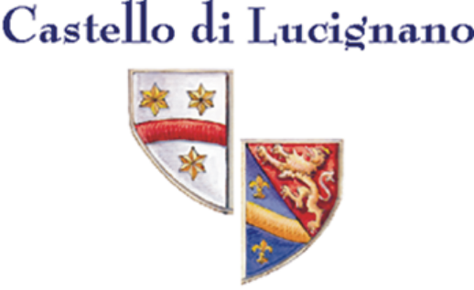

National and international ratings of Castello di Lucignano Wines

National

AIS, Ass. Italiana di Sommeliers

NEW Il Solissimo, IGT 2000 4 of 5 grapes
NEW Chianti Classico Riserva DOCG 2001 4 of 5 grapes
NEW Chianti Classico DOCG 2002 4 of 5 grapes
Il Solissimo, IGT 1999 4 of 5 grapes
Chianti Classico Riserva DOCG 2000 4 of 5 grapes
Chianti Classico DOCG 2001 3 of 5 grapes

Gambero Rosso / Slow Food

NEW Il Solissimo IGT 2000 2 glasses
Il Sommo IGT 2000 1 glass
NEW Chianti Classico Riserva DOCG 2001 1 glass
NEW Chianti Classico DOCG 2002 1 glass

I Vini di Veronelli

 Il Solissimo, IGT 1999 91 Points (preferred wine of Luigi Veronelli)
 Il Solissimo, IGT 2000 89 Points (preferred wine of Luigi Veronelli)
  Chianti Classico Riserva DOCG 2000 89 Points 
 ♣ Il Sommo, IGT 2001 87 Points
  Chianti Classico DOCG 2002 87 Points

Luca Maroni

Il Sommo, IGT 2001 80 of 90 Points

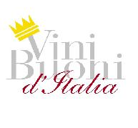
NEW Vini Buoni d’Italia 2005

Chianti Classico Riserva DOCG 2001 Gold-Crown and 4 of 4 stars
(one of the 12 best wines in tuscany, only 95 crowns in Italy by over 3.000 tasted wines)
Chianti Classico DOCG 2002 3 of 4 stars

Page 2

International

Decanter (Great Britain)

Chianti Classico Riserva DOCG 2000 4 of 5 Stars (highly recommended)
Chianti Classico Riserva DOCG 1999 4 of 5 Stars (highly recommended)

Falstaff (Austria)

Il Sommo, IGT 2002 89 Points
Chianti Classico Riserva DOCG 1999 89 Points
Il Solissimo, IGT 1998 89 Points

Merum (Germany, Switzerland, Austria)

NEW Chianti Classico DOCG 2002 3 Stars
(recognized as best Chianti
Classico with 6 other producers of 2002,
83 Wines were tested)

Mondo (Germany)

Il Solissimo, IGT 1999 88 Points
Il Sommo, IGT 2001 89 Points

Smag & Behag (Denmark)

Chianti Classico DOCG 2001 4 of 5 Glasses
Chianti Classico Riserva DOCG 1999 4 of 5 Glasses

Tastings (USA)

Il Solissimo, IGT 1998 90 Points (exceptional)

The Wine Review (Singapur)

NEW Chianti Classico DOCG 2001 Bronze Medal

Vinum (Switzerland)

NEW Chianti Classico Riserva DOCG 2001 16,5 Points

Feinschmecker 2003 (Germany, Jens Priewe)

Rated as one of the best 200 Wineries in Tuscany

Alles über Wein 2003 (Germany)

Gold Medal as a highly recommended Winery in Tuscany

Mondo 2003 (Germany, G. Eichelmann, Dr. S. Maus)

Recognized as one of the best 100 Wineries in Tuscany

